Challonge manages the creation part best,
http://challonge.com/tournament/bracket_generator
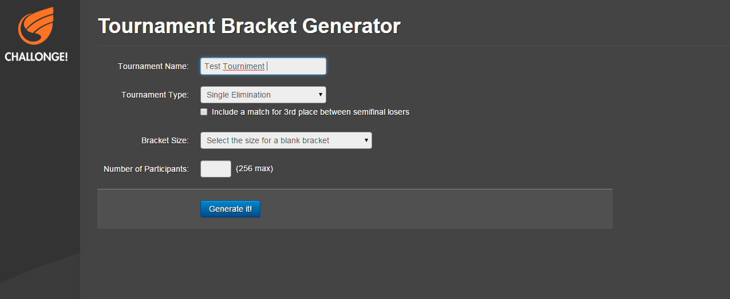

So you type in a name and select a type :
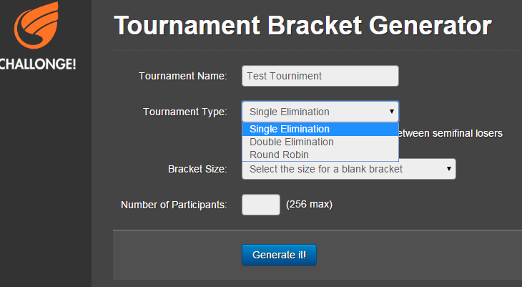

And then the number of participants then feed into the code given by the GitHub project I shared to generate the brackets (Seeds with default names of “Participant”)
Once the seeds have been created, then the management as seen in bracket ninja is the best going forward.
https://app.bracketsninja.com/#/
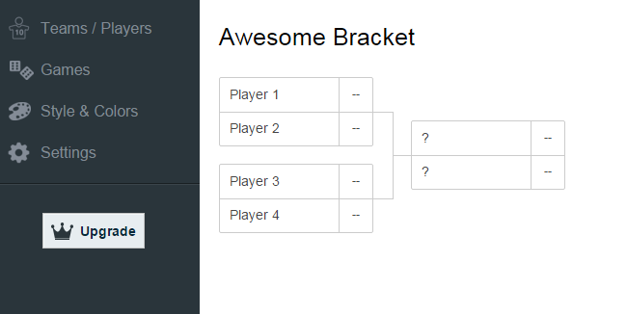

The players/Teams can each be renamed on the players menu Item.
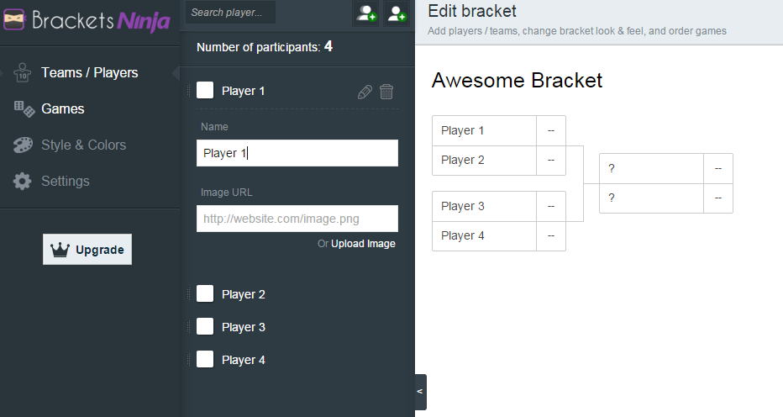

Please play with this and see how you can change player names and images,

Games can also be edited
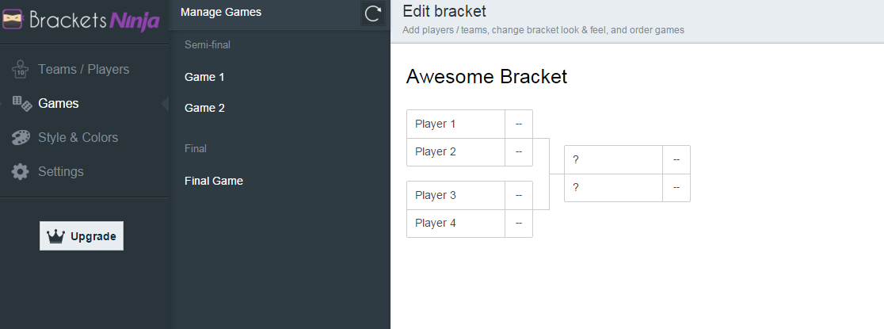

And changed to display “Grand Final” and so forth.
But most importantly from this website is the game management. When clicking on a seed.
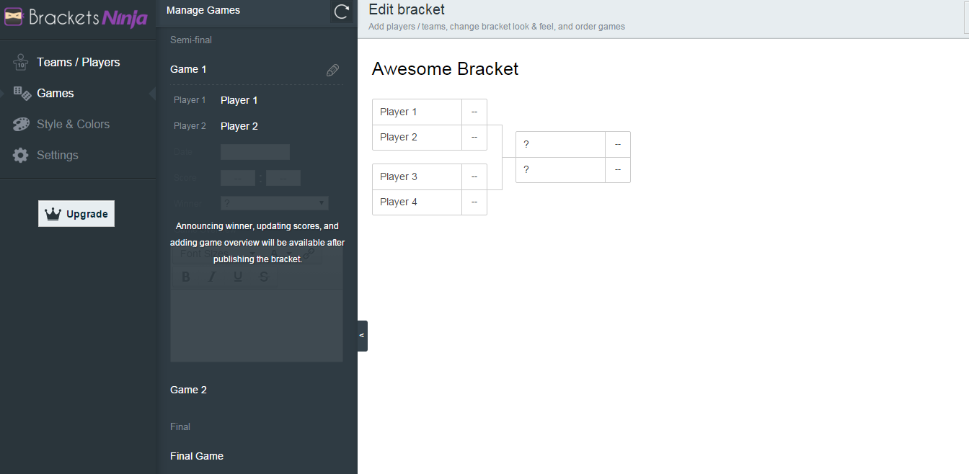
These will be used to determine what team/players win their games. So if a game is marked as best of 3, then only once the total score adds up to 3, then determine the winning by who has the bigger score.

Then the bracket as seen on Toornament
https://www.toornament.com/tournaments/55ffc839140ba0d6238b4568/
The participants and seeds that were just generated, need to then read into the same type of screen as seen on toornament. (“Click on playoffs”, if you can’t see this screen.)
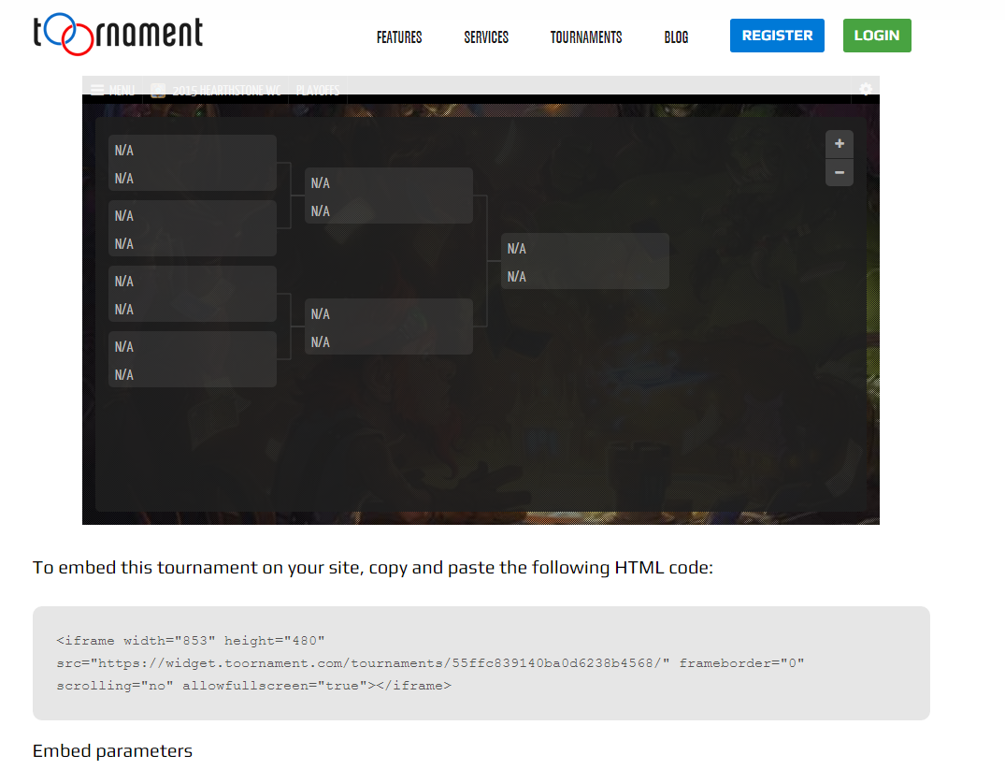
The “N/A”, will then need to be replaced by the Participants names obviously. This also needs to have a full screen button to expand it to full screen. (Hover over right corner at on the screen). Also from that page, if we can include the following details upon creating the tournament:
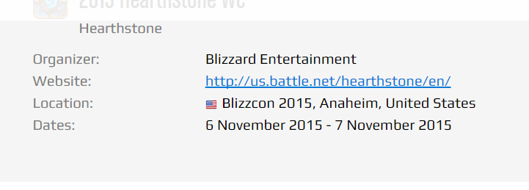

Then once you click on a seed as seen on tournament, it needs to display the two participants for that game as well as the current score (default being 0), and then the scheduled time and date for this match. (example is not as requested, but should look fairly similar).
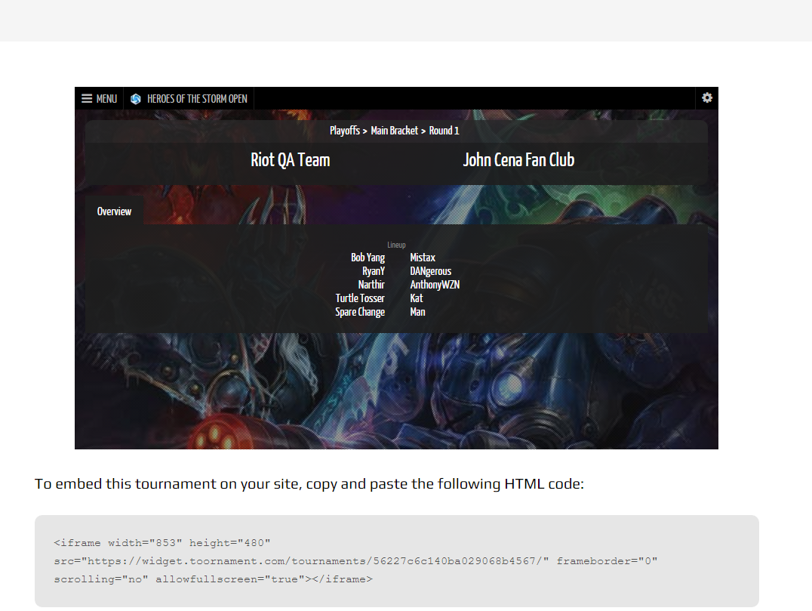

So that will need to be the flow that follows.

